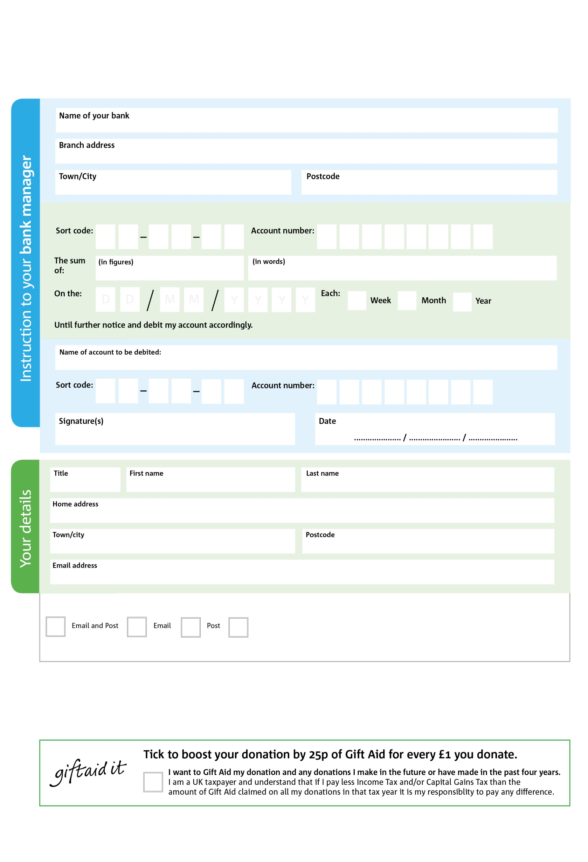

I do not wish to receive future communications from Walton and Hersham Foodbank

**Please pass this form onto the foodbank, using the foodbank’s address at the bottom, who will save a copy for their records.   
They will then send it onto your named bank or building society.**

**Standing Order Mandate**

**www.waltonhersham.foodbank.org.uk**

0000000

V

30

POSTAL ADDRESS: No 2 Quintet, Churchfield Road, Walton on Thames, Surrey KT12 2TZ

Please pay Walton and Hersham Foodbank,

Reg. Charity No: 1131361 | Reg. in England & Wales

4444

V

2222

V

3333

V

44444

V

4444

V

1

V

00001

V

9

0

9

9

0

We would love to keep you up to date with information about Walton and Hersham Foodbank. Please tick your preference:

You can change your preferences any time by contacting us on [0203 328 0243 / 07884 046665](mailto:0203%20328%200243%20/%2007884%20046665) or emailing us at [info@waltonhersham.foodbank.org.uk](mailto:info@waltonhersham.foodbank.org.uk)

**Data protection**

Walton and Hersham Foodbank is committed to protecting your privacy and will process your personal data in accordance with current Data Protection legislation. Walton and Hersham Foodbank collects information to keep in touch with you and supply you with information relating to our work. To unsubscribe from our newsletter, send a message to the email address above with the word unsubscribe in the subject line. A full data privacy statement for financial donors is available from the foodbank on request.

You can change your preferences any time by contacting us on XXXXXXXXXXX or emailing us at XXXX@XXXXXXXXXX.foodbank.org.uk

I do not wish to receive future communications from XXXXXX Foodbank